# **What is Terraform :-** **Terraform is an infrastructure as code tool that lets you build, change, and version cloud and on-prem resources safely and efficiently.**

# **Why Terraform:- We can use Terraform to efficiently deploy, release, scale, and monitor infrastructure for multi-tier applications**

# **Benefits of Terraform:-**

# **Collaboration and Access Control.**

# **Remote State Management.**

# **Version Control Integration.**

**ASSINGMENT 1-** 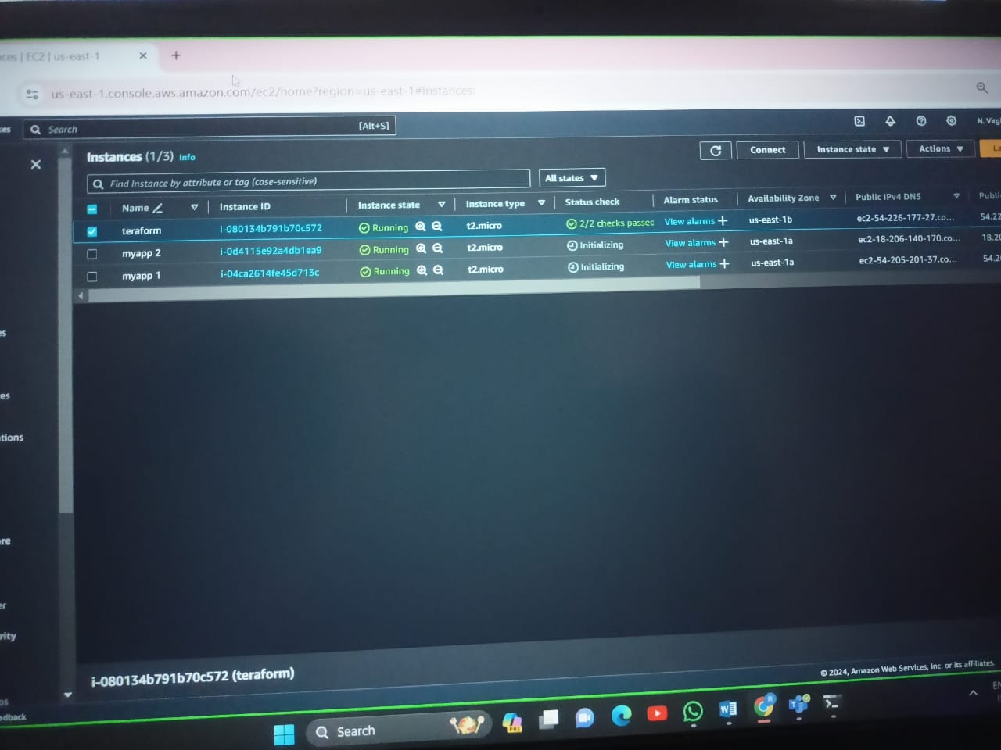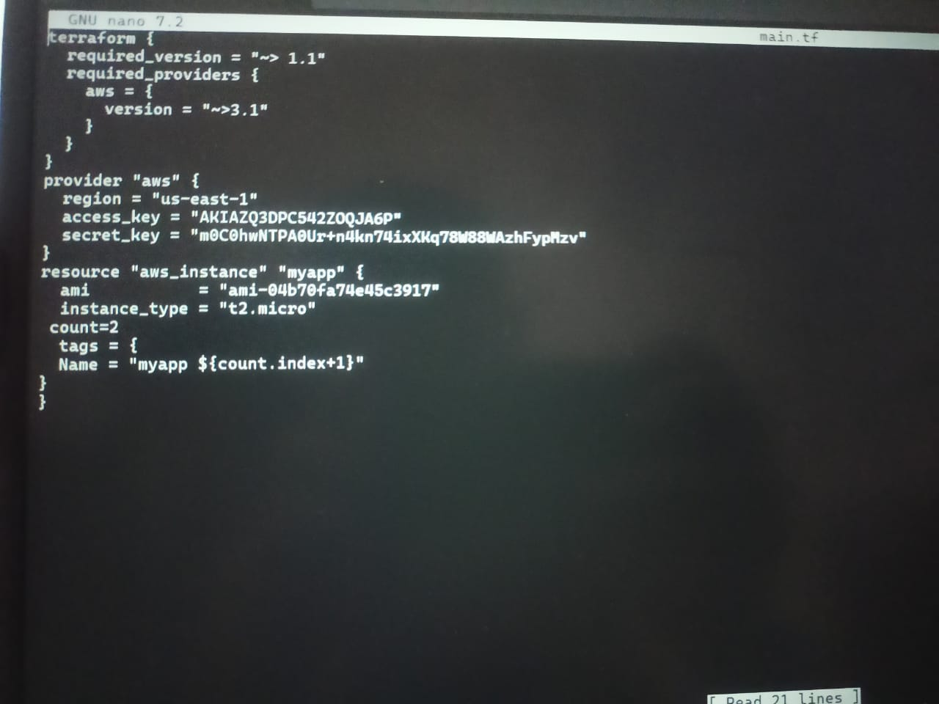

**Assingment 2-**

